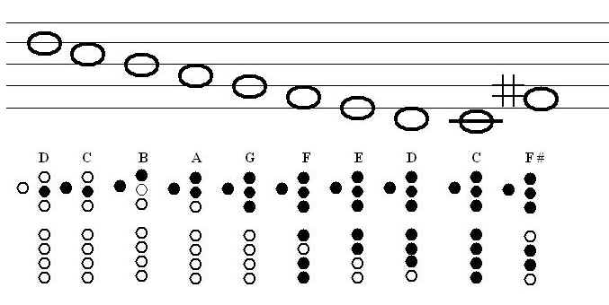
Practice Lion Sleeps Tonight Melody
Pg. 29 Ode to Joy, First 2 lines
Pg. 25 #50
Patterns, Engine Engine Number 9
Engine D, B
Pg. 29, #60 Farbod Challenge Mr. Ungvary

